TASK

Objective Questions:

1. What is the total no. of tables present in the data?

Answer: Based on the structure of the data received, the call centre data is maintained in a single consolidated table

1. What is the total no. of attributes present in the data?

The original dataset had 34 columns, and after cleaning and creating new derived columns, the final cleaned data contains 30 columns

1. The data consists of some inconsistent and missing values so ensure that the data used for further analysis is cleaned.

Answer: The dataset was cleaned by handling missing values, removing duplicates, standardizing text formats, and creating derived columns for accurate analysis.

Data has been cleaned with the help of different excel functions Aggregate functions, Logical functions, Condition aggregation, Text functions, Date functions, Lookup functions, TRIM, PROPER.

1. Change of Names of Columns

* uid – User ID
* gid – Guru ID
* guruName – Guru Names
* chatStatus – Chat Status
* consulation Type – Consultation Types
* chatsecond – Chat Second
* refundStatus– Refund Status
* createdAT – CreatedAT
* website – Websites
* freeChat – Free Chat
* callStatus – Call Status
* chatStartTime – ChatStart Time
* chatEndTime – ChatEnd Time
* freeCall – FreeCall
* callChannel – Call Channel

1. Removed Columns –

* _id
* user
* guru
* isWhiteListUser
* queue
* _v
* statementEntryId
* timeDuration

1. Extracted Columns – From CreatedAT with Text Function

* Created Hour
* Created Date
* Created Year
* Created Month
* Created Time

1. Missing Values –

* There were blank spaces in the column Chat Status, Chat Seconds, ChatStart Time and ChatEnd Time. As the blank spaces shows the call service taken, so the missing values in these columns are filled with “Call Used.” In some cells chat is used but no info is provided so those blank spaces are filled with “Not available”.
* There were blank spaces in the column Call Channel, Call IVR Type, Call Status, Astrologer Call Status, Astrologer on Call Duration, User CallStatus, User on CallDuration, Region, Astrologers Earnings, CallSid. The missing values in these columns are filled with “N/A”.
* There were blank spaces in the column Amount, Net Amount. The missing values in these columns are filled with “0”.

The missing Value of cells is calculated using Logical Operation.

IF(ISBLANK(cell_reference), value_if_blank, value_if_not_blank)

1. What is the change in daily call volume day by day and also find the average daily call volume. 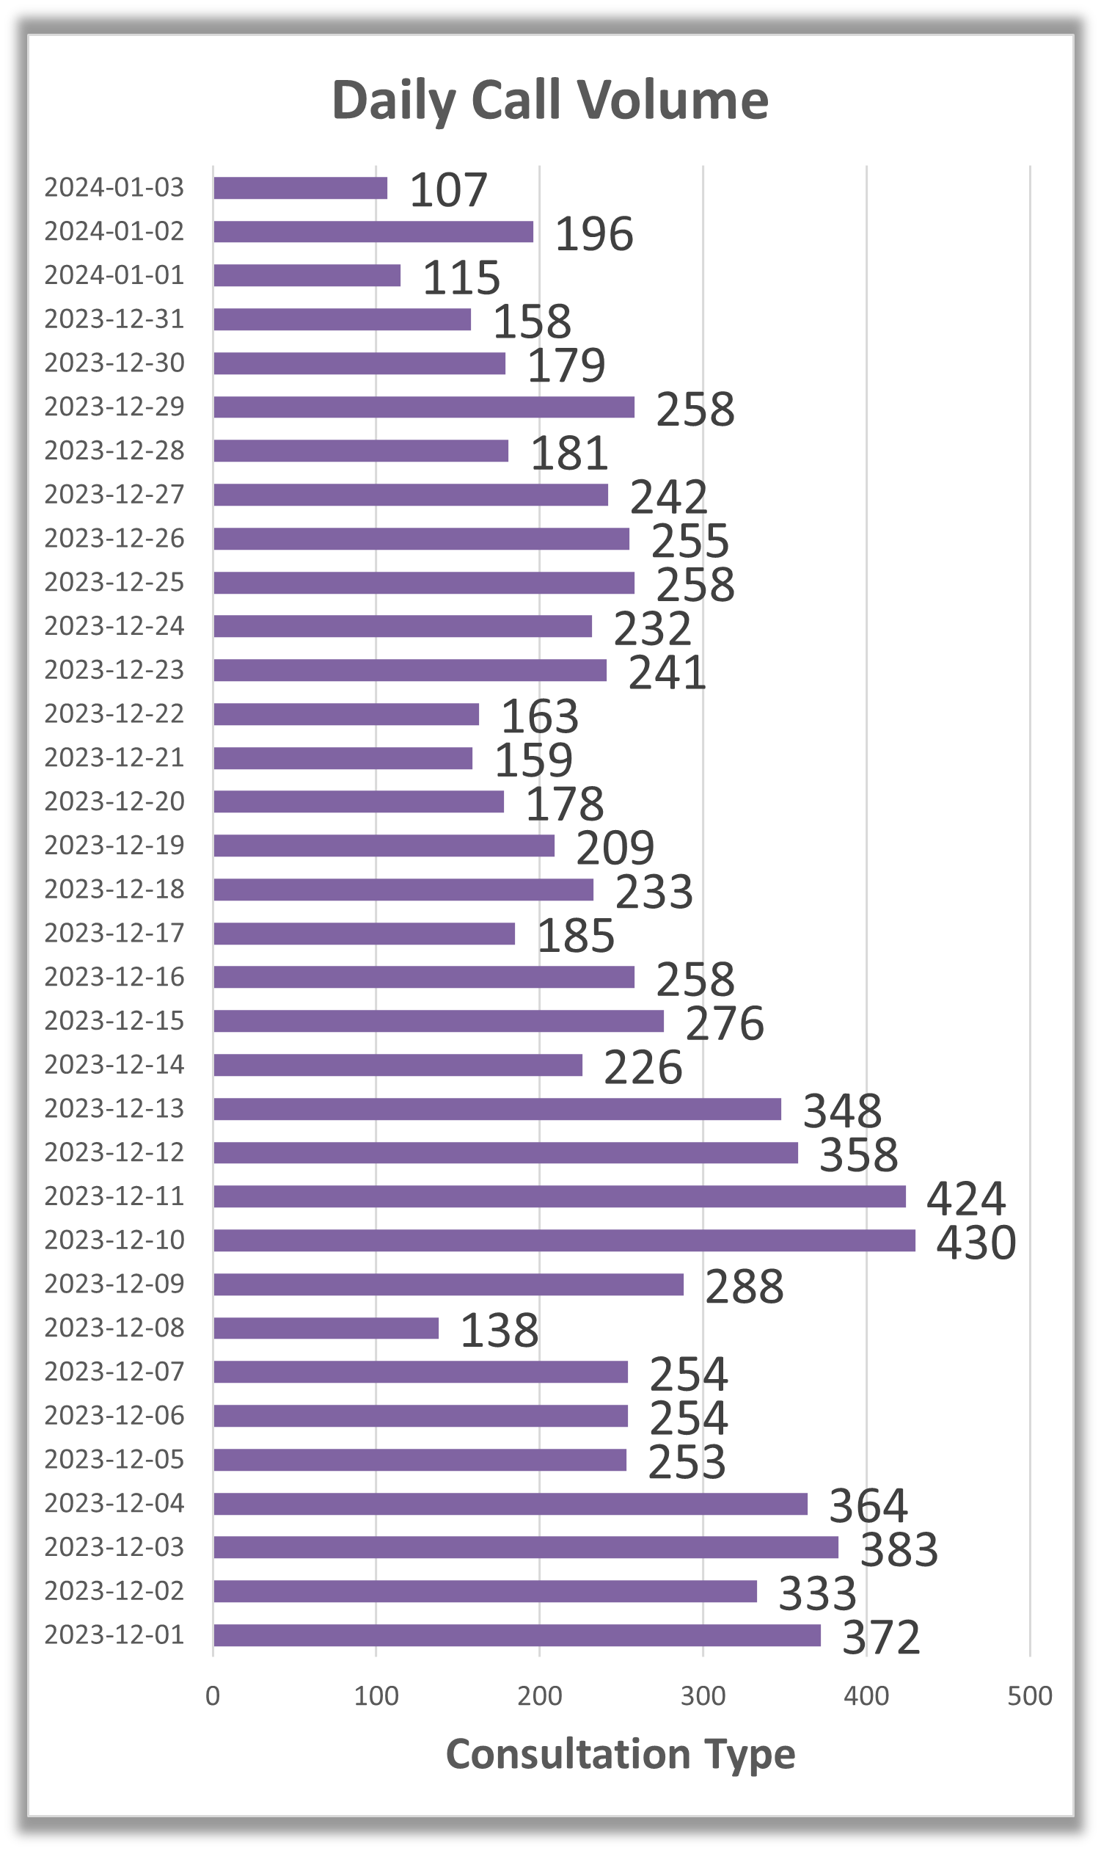 A screenshot of a data

   AI-generated content may be incorrect.

Answer. Average Daily Call Volume = 250.24, And See Daily Changes in Above Formatting.

1. Which months experienced the highest and lowest call volumes?



1. What is the total operational cost for that month?

Answer. Amount as cost (assuming this includes operational cost).



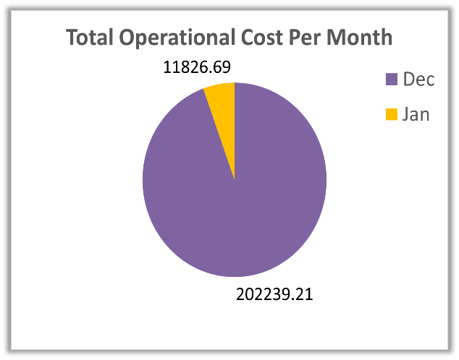

1. What is the average number of calls handled per agent per day?

Answer: Average Call Handled Per Agent Per Day = 2.25



1. How many repeat callers are there, and what percentage of total calls do they represent?

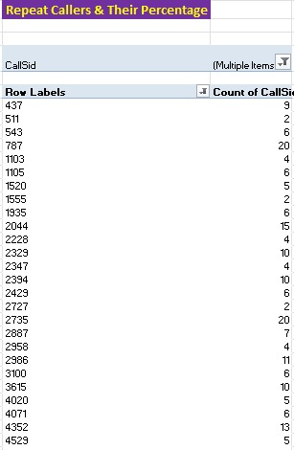

Answer.

Total number of callers=3628

Formula used =COUNT ()

Now we have to find the repeater callers. The callers who use the call service more than one time,

For that we can apply the filter on the pivot table in the user id section, which will show the callers

who called more than one time.

Repeater callers = 1275

Formula used- =COUNT ()

PERCENTAGE OF TOTAL CALLS –

Total number of calls = 8365 (count of calls)

Caller placed 6012 repeated calls.

Repeated calls = 6012 – 1st call placed by callers

= 6012 – 1275 (count of repeated callers)

Repeated calls = 4737

Percentage of repeated calls = (Repeated calls/Total calls) *100

= (4737/8365) *100

Percentage of repeated calls = 56.63 %



1. What are the total sales generated by the call centre for each product category?

Answer: Total Sales = 214065.90



1. How many calls were made for each user ID and guru ID?

Answer: The mentioned pivot tables identify the number of calls done by each user and each guru respectively. And For more information refer to Excel Dataset, Sheet Pivot Table with headers as shown in the given picture.



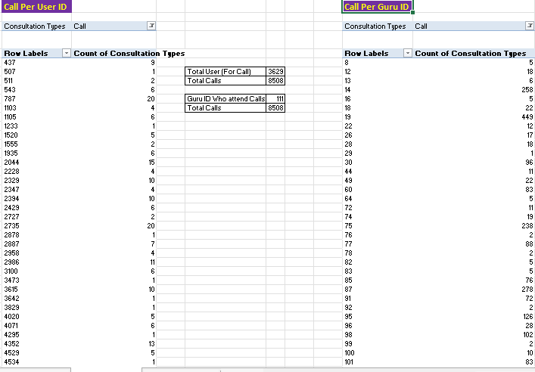

1. What is the correlation between call duration and customer satisfaction?

Answer: The correlation between call duration and customer satisfaction is derived by the

correlation function: CORREL('Cleaning Data'!Y2:Y28028,'Cleaning Data'!AD2:AD28028)

Correlation between Call Duration and Satisfaction = -0.000202451  
This represents there is an extremely small inverse correlation between the two attributes which can be neglected a can determine there is no relation between the two attributes.

1. Which guru has the highest and lowest customer satisfaction scores?

Answer:



1. What is the average customer satisfaction score by month?

Answer: Dec Avg. Rating = 2.95

Jan Avg. Rating = 2.68

1. How many categorical columns are there in the data? [Search about categorical and continuous data, and try to answer this question]

Answers: Categorical Column = 14 in the Cleaned Data

Column Names are –

1. Guru Name
2. Websites
3. Consultation Types
4. Created Month
5. Refund Status
6. Chat Status
7. Free Chat
8. Free Call
9. Call Channel
10. Call IVR Type
11. Call Status
12. Astrologer Call Status
13. User Call Status
14. Region

Subjective Question:

1. Should the investment be used to hire more agents, improve training programs, or upgrade call center technology?

Answer. 1) Hiring more agents



Average Daily Call Volume (Without Public_Live_Call) = 250.24

As Per Agent Only 3453 Call Completed and Rest are consider as not completed(failed etc)

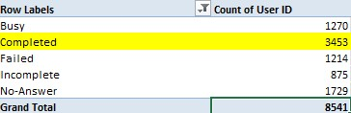

% of calls gets complete = 40.43 % [Formula= (Completed calls / total calls) *100]

Call centre receive approx. 250 calls per day but only 40.43% of calls gets complete in total. There is a need of investment in the hiring of agents to manage the workload.

2) Improve Training Programs

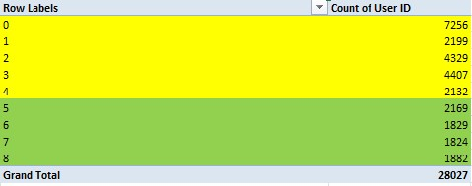

Only 27.49% of users are satisfied with the service.

Total users = 28027

Satisfied user (Rating-5,6,7,8) = 27.49 %

Unsatisfied user (Rating-0,1,2,3,4) = 72.51 %

Pivot Tables Show the detail and Rating (0to4) = 72.51% (20323)

Rating (5to8) = 27.49% (7704). It shows the low satisfaction scores.

The Investment should be used to improve training program.

3) Upgrade Call Center Technology

  

Currently, 69.62% of users rely on the chat service, which highlights its importance. At present, Gurucool is the only platform offering this feature. However, its average user rating stands at just 2.71, indicating widespread user dissatisfaction. To address this, it is essential to invest in technology upgrades. Improving the platform’s functionality and user experience can lead to higher user satisfaction and better retention rates. While there are risks associated with upgrading technology, the potential benefits in terms of user engagement and overall performance make it a necessary step forward.

1. What are the potential risks of each investment option (hiring, training, technology upgrades), and how can they be mitigated?

Answers.

1. Hiring More Agents:
   * Risks:
     + High Turnover: Newly hired agents may not stay long, leading to increased hiring costs.
     + Quality Control: Rapid hiring may compromise the quality of recruits.
     + Increased Operational Costs: Higher salaries and benefits add financial burden.
   * Mitigation Strategies:
     + Implement a robust recruitment process focusing on skill assessments and cultural fit.
     + Develop retention strategies such as career development opportunities and competitive compensation packages.
     + Consider part-time or temporary hires to manage peak periods without long-term commitments.
2. Improving Training Programs:
   * Risks:
     + High Costs: Developing comprehensive training can be expensive and time-consuming.
     + Ineffective Training: Programs may not yield the desired improvement in performance.
     + Resistance to Change: Employees may resist adopting new skills or methodologies.
   * Mitigation Strategies:
     + Pilot the training program with a small group and measure effectiveness before a full rollout.
     + Use a mix of learning methods (online, in-person, peer training) to cater to different learning preferences.
     + Engage employees in the planning process to increase buy-in and alignment with their development goals.
3. Upgrading Call Center Technology:
   * Risks:
     + Implementation Challenges: New systems might disrupt operations during the transition.
     + High Costs and Complexity: Technology upgrades can be costly and complex to integrate with existing systems.
     + Dependence on Technology: Over-reliance can lead to issues if technological failures occur.
   * Mitigation Strategies:
     + Plan and communicate the implementation process clearly to minimize disruption.
     + Conduct a phased rollout allowing for testing and adjustment.
     + Partner with trusted technology providers offering continuous support and training for your staff.
4. How does AstroSage's call center performance compare to AstroGuru's average call volume, customer satisfaction, and agent performance?

Answer. The Average call volume per day is 250 calls. There are 131 gurus who can receive calls.

But out of 8541 total calls only 3453 calls are getting completed, which is 40.43 %.

Also Customer satisfaction for Call Avg. Rating is 3.5. If problems resolve quickly and agent is well trained for problem solving both conditions will give growth to company in compare of AstroGuru.



Will you use any aggregation function or a visualization here to solve the problem?

Answer. We can use AVERAGE(),COUNT(),Pie Chart.

1. How can the call center improve its handling of peak call periods to ensure high customer satisfaction?

Answer. Checking Peak Hours - As we can see 5 AM to 4 PM we have the Highest Call Volume.

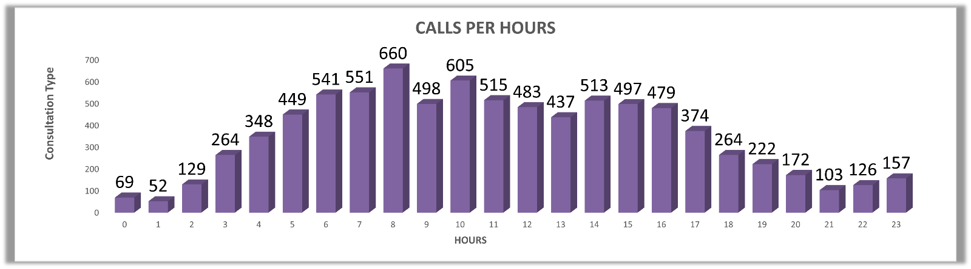

Here we can see the hourly distribution of calls. First we have to take out hours from created AT with the help of = TEXT FUNCTION , later by taking hours in row , count of calls in values and consultation type in filters and set that filter as call. This is how we can form the pivot table and later with the help of pivot table we can visualize it with chart.

Suggestions:

By identifying peak hours using pivot tables and hourly call distribution, the call center can strategically allocate more staff or automate processes during these periods. Implementing callback options and automated responses for non-urgent issues can alleviate wait time pressure. Real-time dashboards that show queue lengths and agent load help supervisors make timely staffing decisions. Combining human and automated response mechanisms will ensure that all customers are served promptly, regardless of demand spikes.

IN – SHORT

* Shift-based staffing.
* Callback system.
* Auto-replies & chatbots.

1. Based on historical data, what strategic initiatives should be prioritized to improve efficiency and customer satisfaction?

Answers.

Strategy 1 – Training Programs

Only 27.49% of users are satisfied with the service.

Total users = 28027

Satisfied user (Rating-5,6,7,8) = 27.49 %

Unsatisfied user (Rating-0,1,2,3,4) = 72.51 %

Pivot Tables Show the detail and Rating (0to4) = 72.51% (20323)

Rating (5to8) = 27.49% (7704). It shows the low satisfaction scores.



For Improvement -

* Efficient Call Handling: Train astrologers to manage calls effectively, reducing duration without affecting service quality.
* Skill Enhancement: Improve employee communication and service skills for better customer interactions.
* Scalability Support: Prepare staff to adapt to new tools and processes as the service expands.

Strategy 2 – Upgrading Technology

  

* High Chat Usage: 69.62% of users depend on the chat service, showing its critical role.
* Single Provider: Gurucool is the only platform offering this feature.
* Low User Satisfaction: Average rating of 2.71 indicates dissatisfaction.
* Need for Upgrade: Tech improvements are essential to enhance user experience and retention.
* Growth Potential: Despite risks, upgrades can boost engagement and overall performance

Strategy 3 – Optimizing Call Peak Hours





As we can see on Peak hours 5 AM to 4 PM we have the Highest Call Volume. Only 40.43%

(completed call / total call) *100] of users got service and rest is seen as they didn’t get any

services.  
For Improvement -

* Shift-Based Staffing: Implement scheduled shifts to ensure consistent service availability and reduce agent fatigue.
* Callback System: Allow users to request callbacks during high-traffic times, improving customer convenience and reducing wait times.
* Auto-Replies & Chatbots: Use automated responses and AI-driven chatbots to handle basic queries instantly and reduce response delays.

Implementing shift-based staffing, callback systems, and automation tools like chatbots ensures smoother operations and better user experience. These strategies help manage high volumes efficiently while maintaining service quality.

1. What can be the key factors contributing to high customer satisfaction scores, and how can these be leveraged to improve overall performance?

What is the basis for the suggestions? And mention how you decided if the satisfaction score affects the ratings.

Answers.

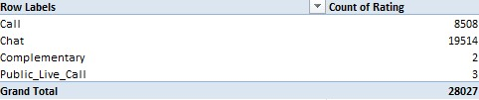

Total users use chat service = 19514(69.62 %)

Rating of 6,7,8 is considered as the high satisfaction range.

Only chat service receives the rating of 6,7,8

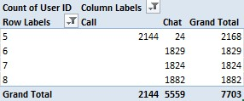

  

Since 69.62% of total users prefer the chat service, and 100% of high satisfaction scores come from chat users, it is evident that the chat service is a key contributor to customer satisfaction.

* High Chat Usage: 69.62% of users depend on the chat service, showing its critical role.
* Single Provider: Gurucool is the only platform offering this feature.
* Low User Satisfaction: Average rating of 2.71 indicates dissatisfaction.

Recommendation for Improvement:  
To further enhance user experience and overall performance, the company should:

* Need for Upgrade: Tech improvements are essential to enhance user experience and retention.
* Growth Potential: Despite risks, upgrades can boost engagement and overall performance
* Introduce AI-powered chatbots to handle routine queries efficiently.
* Train employees to adopt new tools, technologies, and processes that support scalability and quality service.

These steps will help drive higher customer satisfaction, improve operational efficiency, and support sustainable growth.

1. How should the call center balance the workload among agents to ensure optimal performance and avoid burnout?

Answer. Analysis of the pivot table showing daily calls per agent reveals uneven call distribution, leading to agent fatigue and inconsistent performance. Some agents are overburdened, while others remain underutilized.

To address this issue, it is recommended to implement shift-based staffing, a callback system, and automation tools such as chatbots. These measures will help balance workloads, improve operational efficiency, and enhance the overall user experience.

.



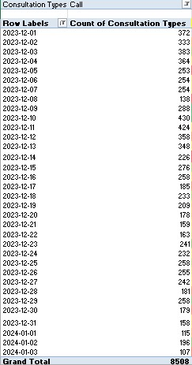

Average number of calls per day = 250 (Formula - =AVERAGE())

Average Call Handled Per Agent Per Day = 2.25

COUNTIF we can use to find agent only for Call .

For Improvement -

* Shift-Based Staffing: Implement scheduled shifts to ensure consistent service availability and reduce agent fatigue.
* Callback System: Allow users to request callbacks during high-traffic times, improving customer convenience and reducing wait times.
* Auto-Replies & Chatbots: Use automated responses and AI-driven chatbots to handle basic queries instantly and reduce response delays.

Implementing shift-based staffing, callback systems, and automation tools like chatbots ensures smoother operations and better user experience. These strategies help manage high volumes efficiently while maintaining service quality.

1. What new technologies or tools could be implemented to enhance call center operations and customer service?

Answer. New Technologies & Tools for Call Center Optimization

1. Cloud IVR & Smart Routing

* Routes incoming calls based on caller history, query type, and agent expertise.
* Reduces wait time and improves first-call resolution.
* Enhances customer satisfaction by connecting to the most suitable guru quickly.

2. CRM Integration

* Provides agents with caller history, previous issues, and preferences in real-time.
* Enables more personalized and informed conversations.
* Speeds up problem-solving and builds customer trust.

3. AI Chatbots

* Handles common, repetitive queries (e.g., billing, session timings).
* Operates 24/7, ensuring basic support even during non-working hours.
* Reduces workload on human agents, allowing them to focus on complex issues.

4. Real-Time Dashboards

* Displays live metrics such as call queue length, average handling time, and agent availability.
* Allows supervisors to intervene quickly in high-load scenarios.
* Helps balance call loads and prevent service dips during peak hours.

5. Predictive Dialers

* Automatically dials outbound numbers, skipping unanswered or busy lines.
* Connects agents only when a call is live, reducing idle time.
* Ideal for feedback collection, promotions, or appointment confirmations.

Impact: These tools together boost efficiency, response time, and customer satisfaction, while reducing manual overhead and improving agent productivity.

1. What metrics should be included in the final dashboard to comprehensively view call center performance and guide investment decisions?

Answer.

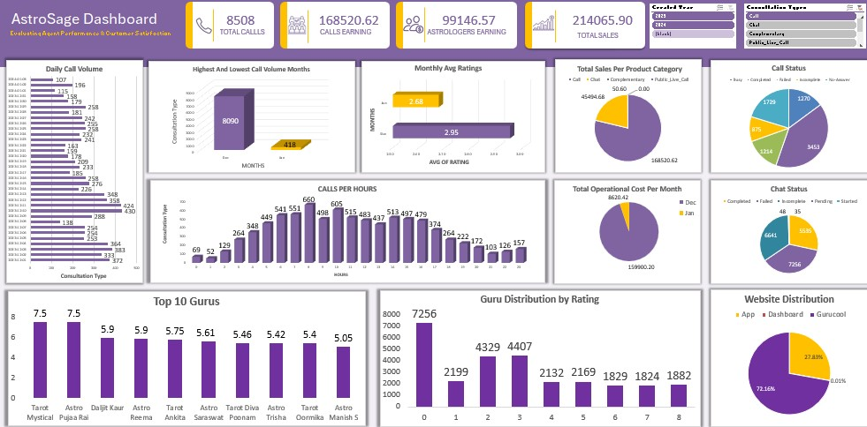

Metrics that are included in Dashboard-

KPI (Key performance indicator) – 1. Total Calls

2. Total Cost

3. Astrologer Earning

4.Calls Earning

1. Changes in Call Volume Day by Day

It shows daily fluctuations in the number of calls.

1. Highest And Lowest Call Volume Months

Displays the months with the maximum and minimum number of calls.

1. Total Operational Cost Per Month (Amount as cost (assuming this includes operational cost).

Shows monthly spending on operations.

1. Total Sales Per Product Category

Breaks down total sales revenue by consultation status providing insights into which services are performing best.

1. Monthly Avg. Ratings

Shows the average user ratings received per month

1. Call Status on User ID

Displays the call activity (completed, incomplete etc) linked to individual user IDs,

1. Chat Status on User ID

This tracks the status of chat interactions (complete, incomplete etc) for each user ID

1. Calls Per Hour

Measures the volume of calls distributed across each hour of the day. This helps in identifying high-traffic periods.

1. Top 10 Gurus

Displays the top-performing gurus based on user ratings.

1. Guru Distribution by Rating

It shows how gurus are distributed across different rating (0to8).

1. Website Distribution

It represents the traffic or user engagement across different platforms (App, Dashboard, Gurucool).

1. Slicer On Year and Consultation Type

An interactive filter that allows to view dashboard metrics based on specific years and types of consultations

1. How would you allocate a 1 crore rupee investment to optimize operational efficiency, enhance customer satisfaction, and boost profitability, and what analysis-based recommendations would you offer to support this?

[you have to give bullet pointers to answer this question]

Answer. Here is Strategic Allocation Plan for ₹1 Crore Investment: Enhancing Efficiency, Satisfaction & Profitability

1. Technology Upgrade (IVR, CRM) – ₹35,00,000

* Modernize IVR and CRM systems for better call routing and faster agent access to caller history.
* Reduces dropped calls, wait times, and call misdirection.
* Enhances customer experience through personalization and efficiency.

2. Training & Performance Coaching – ₹25,00,000

* Focused training modules to improve First Call Resolution (FCR) and customer handling skills.
* Regular coaching for low-performing agents and skill refreshers for all.
* Directly improves customer satisfaction and agent confidence.

3. Automation (AI bots, Call Scheduling) – ₹20,00,000

* Implement AI chatbots for handling FAQs and low-priority queries.
* Introduce auto-scheduling and callback systems during peak hours.
* Frees up agents for complex calls and ensures faster resolution.

4. Strategic Hiring (Peak-Time Staffing) – ₹15,00,000

* Hire trained part-time or on-demand agents for high-traffic periods.
* Prevents overload on existing staff, improving quality and morale.
* Cost-effective: only add workforce when needed.

5. Analytics & Monitoring Systems – ₹5,00,000

* Real-time dashboards and analytics for performance monitoring.
* Helps in tracking KPIs like call volume, duration, satisfaction scores.
* Enables management to make timely, data-backed decisions.